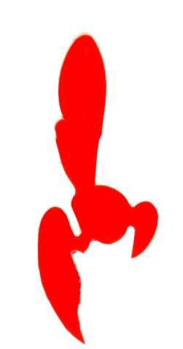
Hornet Class Association Membership Application Form 2021

Name: ____________________________________________________I am Helm/Crew

Address: ________________________________________________________________

_______________________________________________________________________

Post Code: _________________________ Telephone: ___________________________

Email Address: ___________________________________________________________

Sail Number: __________ Sailing Club: _______________________________________

My regular Helm/Crew is: __________________________________________________

Address: ________________________________________________________________

Email Address: ___________________________________________________________

I am applying for (please ✓ appropriate box/boxes)
- Full membership/Crew membership @ £35.00
- Junior membership (under 21years on 1/1/2021) @ £17.00
- Social membership (non-sailing) @ £17.00

By signing this form, you agree that the association may contact you by email to deliver the class magazine (Mainsheet) and any news or class promotional documents. You also agree that your details, those relevant to the Association’s needs, are included on a Database held digitally, but will be removed if you wish. Please return this form to the Secretary.

Signature: ________________________________ Date: ____________________

Please make cheques payable to:- Or by Bank to Natwest Bank plc
RYA National Hornet Association RYA National Hornet Association
Account :-02503166
Sort Code: 55-50-28
Please return form and payment (exact wording needed for the bank to accept) to:-
Dave Edge (Chair)
4 Greenways
Southampton SO16 2NY

